Open the Disease Lab simulation on your device.
- Notice the default parameters:
  - Disease: Kold (a fictional representation of the common cold)
  - Population Density: Medium
  - Population Mixing: None
- For the first set of runs, keep the default parameters.
- Run the simulation three times (*Note: You can watch the spread slowly by using the ‘Step’ button). Notice how the colors change over time. This represents a change in the health status of each individual.
- At the end of each simulation, record your data in the table below.
- Reflect on how a medium population density affected the spread of the Kold. *You do not need to write anything. Just think about it!
  - Did you get the same results each time? Why do you think the results varied?
  - The Kold lasts five days. How did this affect your results?
  - What would happen to the results if there were fewer people? Why do you think this?
  - What would happen to the results if there were more people? Why do you think this?
- Change the population density to low. Run the simulation three times and record your results.
- Change the population density to high. Run the simulation three times and record your results.

Activity 2: Virtual Ecosystem Data Sheet
Population Density | Population Number | Starting Number of Contagious People | Sick Days Reported | Ending Number of Contagious People | Contagion Rate  (per capita)
Medium
Run 1
Run 2
Run 3
Low
Run 1
Run 2
Run 3
High
Run 1
Run 2
Run 3

- Open the disease details for the Kold.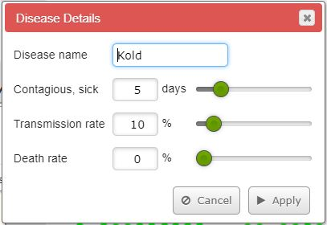
- What do you think will happen if you change these parameters? Why do you think this? (Just think about it. You do not have to write anything down.)

- One at a time, make each of the parameter changes in the table below, and run the simulation with each individual change. Record all observations that occurred based on each parameter change in the table below. Before running the next simulation, click Presets to return all parameters to the default setting. Then, make your next parameter change.
Parameter Change | Observations
Increase the contagious, sick days
Increase the transmission rate
Increase the death rate

- Answer the Conclusion Questions.

CONCLUSION QUESTIONS

CONCLUSION QUESTIONS
- Compare the simulation you completed in The Habitable Planet to the method used in our classroom game in Activity 1. What are some of the benefits to using the computer model versus acting out the model in your classroom?

- How can scientists and public health professionals use computer science to better understand communicable diseases?

- How can computer models help public health officers make recommendations to the public about how to protect themselves from communicable diseases?

